Problem – 1.e)

It was created a node called $Y$ with the expression $e^{U*σ+μ}$, where the $Y$ is the lognormal stochastic variable set, $U$ is the standardized normal stochastic variable set, $σ=0,54087$ is the standard deviation parameter and $μ=2,30259$ is the mean/expectation parameter, both parameters from the $Y \sim lognormal\left(μ,σ\right)$ distribution, which gave us 10000 different $y_{α\%}$ after simulation and its results are plotted in the S-Curve below:

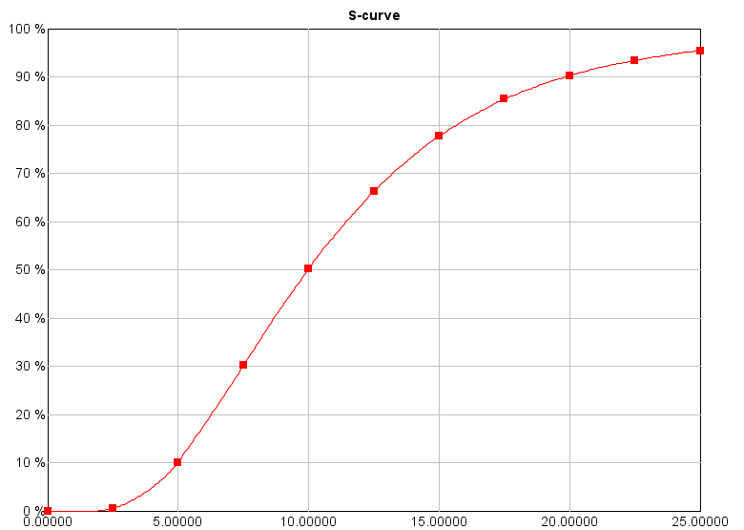

Figure 1. The S-Curve from Riscue Software.

The S-curve shows the cumulative distribution function of the lognormal stochastic variable $Y$ evaluated by $y_{α\%}$ or $P\left(Y≤y\right)=α\%$, which is the probability $α\%$ (in the y-axis) that $Y$ will take a value less than or equal to $y$ (in the x-axis). As expected, the software gave the following results: $y_{10\%}=5$, $y_{50\%}=10$ and $y_{90\%}=20$.

On the other point of view, by the density plot showed below, it is possible to visualize the lognormal equation curve which is positive skewed and with the probabilities of occurrence of each $y$ value (in the x-axis) determined by the area under this curve from minus infinity to $y$ value.

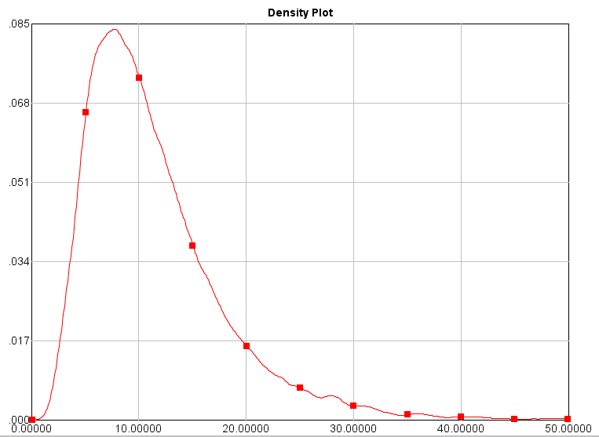

Figure 2. The lognormal density plot from Riscue Software.

Finally, the convergence of the percentiles $y_{90\%} in red, y_{50\%} in green and y_{10\%} in blue$ (in the y-axis) during the 10000 simulations (in % in the x-axis), as showed below:

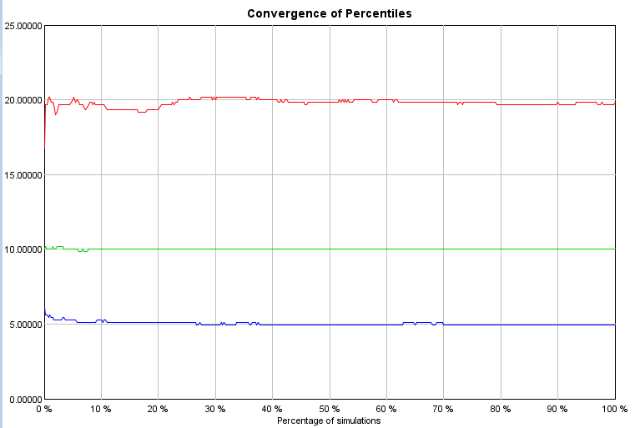

Figure 3. The Convergence of percentiles from Riscue Software.

Here it is showed the speed at which a convergent sequence, in this case the percentiles $y_{α\%}$, approaches its limit. It can be observed that the $y_{90\%}$ approaches its limit at the value 20, the $y_{50\%}$ at 10 and the $y_{10}$ at 5.

Problem - 1.g)

First, a parameter $c=0,5$ was created to express the correlation between successive terms. Additionally, 2 functions for the constants $a$ and $b$ was created where $a=c$ and $b= \sqrt{1-a^{2}}$. Moreover, a chain of $n=12$ nodes called $U_{n}$ was created, where $U_{1}$ is obtained by the standard normal distribution with $μ=0 and σ=1$ and the others $U_{n} (for n=2, … , 12)$, are obtained by $aU_{n-1}+bW_{n}$ where $W_{n}\sim N(0, 1)$. Finally, 10000 simulations for each $U_{n} (for n=1,…,12)$ were performed and with the results a correlation table was generated:

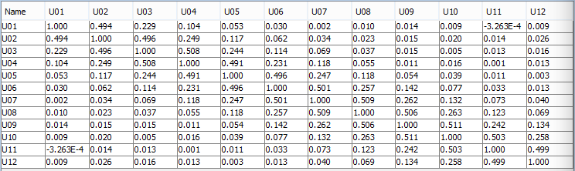

Figure 4. Correlation table from Riscue software.

The scope of the table above is to verify the correlation between any pair of nodes, but here it is focused only on the pair of consecutives nodes which should have a correlation result of 0,5. As contained in the table, any pair of consecutive node got as result $Corr\left(U_{1},U_{2}\right)=0,494; Corr\left(U_{2},U_{3}\right)=0,496; Corr\left(U_{3},U_{4}\right)=0,508; Corr\left(U_{4},U_{5}\right)=0,491; Corr\left(U_{5},U_{6}\right)=0,496; Corr\left(U_{6},U_{7}\right)=0,501; Corr\left(U_{7},U_{8}\right)=0,509; Corr\left(U_{8},U_{9}\right)=0,506; Corr\left(U_{9},U_{10}\right)=0,511; Corr\left(U_{10},U_{11}\right)=0,503 and Corr\left(U_{11},U_{12}\right)=0,499$ which are very approximate to the 0,5 correlation expected. This means that the consecutive nodes are associated with each other and have a measured positive dependence relationship. This is not a surprise, because the expressions of the nodes above represent a time series in which the later node is resulted by a linear combination of the previous node. Furthermore, it is important to notice that the correlation between pairs of consecutive variables are stronger than any other pairs of variables and as far one variable gets from the other as weaker is their correlation, which converge to 0, because $Corr = 0$ means that the variables have not, or very little, dependence relationship.

Problem - 1.h)

The Riscue software is used this time to transform the time series $\left\{U_{n}\right\}$ above in a new time series $\left\{Y_{n}\right\}$ where the variables are lognormal distributed but not identically. A new row of 12 nodes called $Y_{n}$ was created below the first 12 nodes called $U_{n}$. All the new nodes use the formula $e^{σ_{n}u_{n}+μ_{n}}$, where their $μ_{n}and σ_{n}$ were gotten from the figures 5 and 6 below:

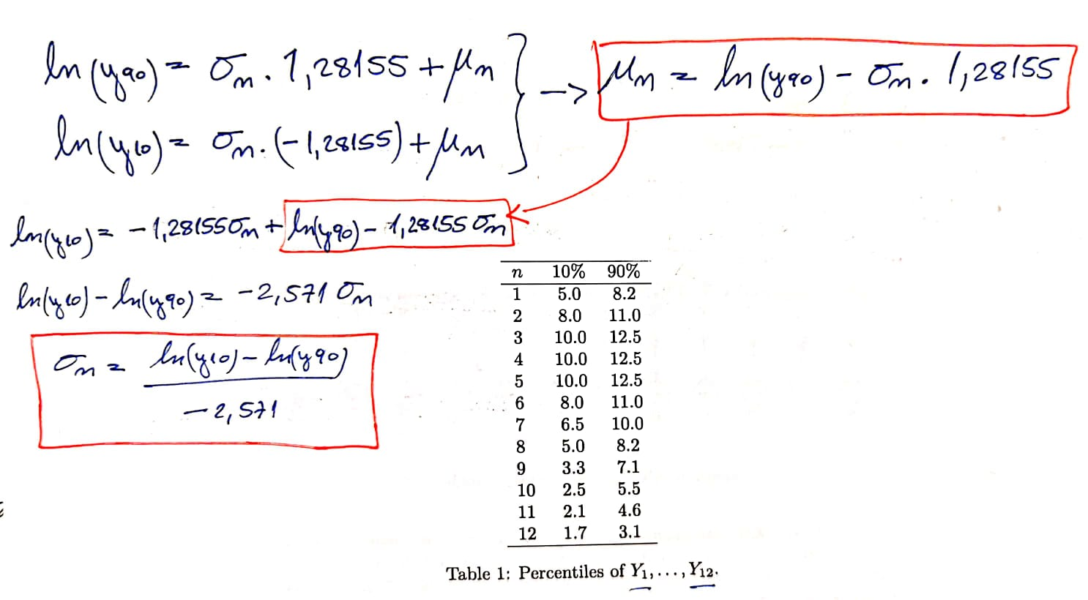

Figure 5. It shows how the $μ_{n}$ and $σ_{n}$ were calculated resulting the next figure.

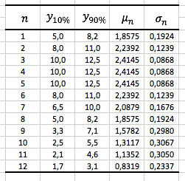

Figure 6 . Percentiles of $Y_{1}, ..., Y_{12}, μ_{n} and σ_{n}$.

Then, 10000 simulations for the new time series $\left\{Y_{n}\right\}$ were run and the following correlation table generated:

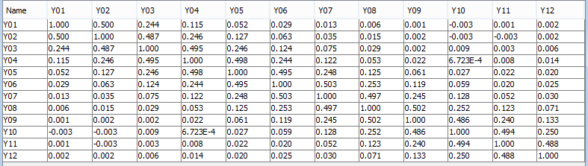

Figure 7. Correlation table from Riscue software.

Once again, the target of this table is to identify measures of dependence relations, positive or negative correlations, between the variables. In this experiment, the correlation between pairs of consecutive variables $Y_{n}\sim lognormal(μ,σ)$ remains stable on approximately 0,5, which means that they are associated and have a positive dependence correlation. As observed in the exercise 1g, this simulation here has also the same comments regarding the correlation strength.

Problem - 1.i)

In this exercise, the time series $\left\{Y_{n}\right\}$ will be considered as the yearly production of oil (in millions of barrel) from an oilfield with “economic life” of 12 years. For that, it was created 3 new parameters for this statistic model in Riscue, the oil price, exchange rate and discount rate, all with the following respectively default values, 18 dollars per barrel, 7.7 NOK per USD and 7%.

Moreover, 3 new nodes were created, “disc. income”, “disc. cost” and “net result” where:

* “Disc. income” is expressed as the product of tree quantities:

1. First, the present value of the yearly production $\left\{Y_{n}\right\}$, in dollars, which is applied the parameter of the discount rate of 7%;
2. Next, the parameter oil price, 18usd, which results the gross profit in dollars;
3. Then, the parameter exchange rate of 7.7, which converts the gross profit from USD to NOK currency.

* “Disc. cost” is acquired from a normal distribution of $μ=6000 and σ=1000$;
* “Net result” is the difference between “Disc. income” and “Disc. cost”.

Then, a sensitive test is run by 10000 simulations for the “Net result”, and the s-curve and density plots are visualized, as following:

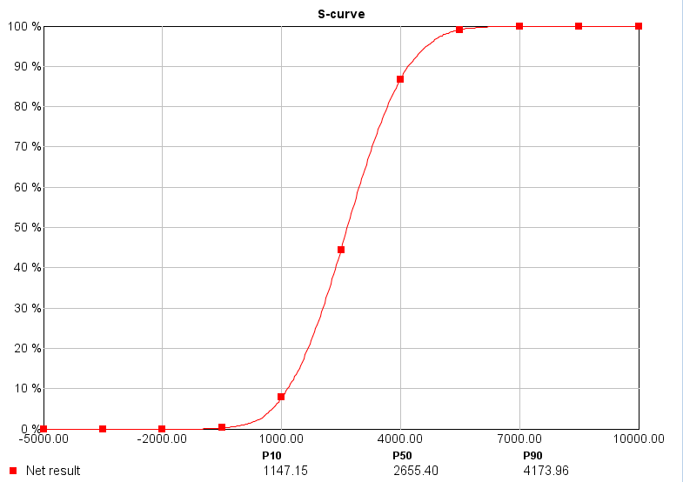

Figure 8. S-curve plot from Riscure software

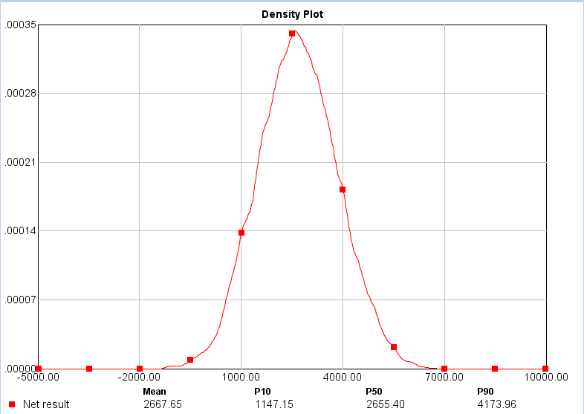

Figure 9. Density plot from Riscue software.

The probability that the net result of the project is less than 1 billion, as visualized in the S-curve plot above, is approximately 9%.

Problem - 1.j)

A sensitivity investigation of the results with respect to variations in the time correlation is implemented now. Here, there are 10 results according to the correlations 0,1, …, 1 respectively, as showed below:

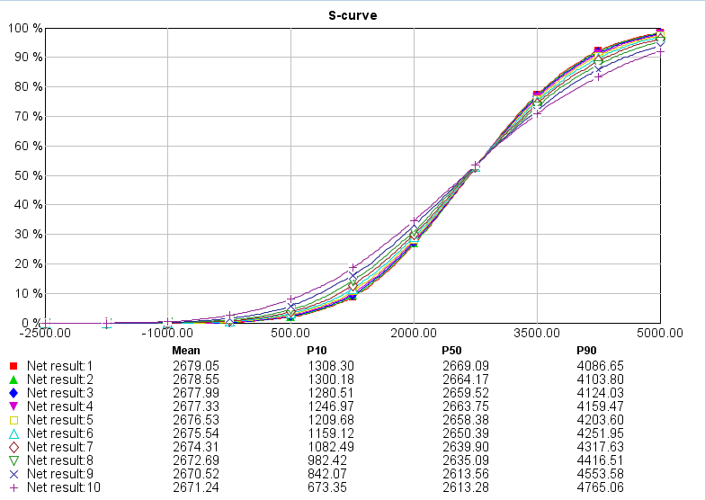

Figure 10. S-curve plot of different correlations parameters, from Riscue software

Firstly, as higher are the correlations as higher are the accumulation probabilities for the net result, for instance, the probability that the net result of the project is less than two billions is around 45% for correlation equals to 1 and 38% for correlation equals to 0,1. However, this is observed until net return equals to approximately 2,8 billions, where the accumulation probability is nearby 55% for all values of correlations. Finally, after 2,8 billions, it is possible to visualize that the lowest correlations start to lead the cumulative probability curve with higher probabilities against net returns. This means that the correlation is relevant between the consecutive early years of the project, but after some point, it turns to be not relevant anymore according to the sensitivity analyze.

Problem - 1.k)

Here, the study will determine how high the oil price needs to be to ensure a positive net result. In the Riscue software, the parameter oil price is switched to multivalued with prices 8,10, 12, …, 20 dollars per barrel of oil.

Again, the 10000 simulations of the net result were run and a line chart plot created:

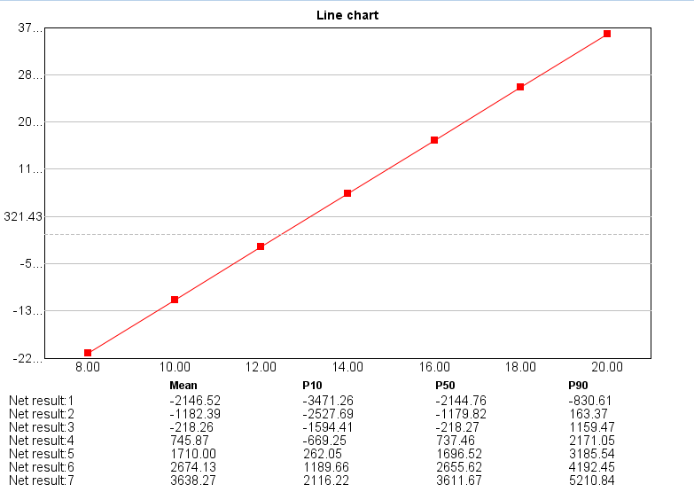

This plot shows that the price of the barrel of oil should be higher than approximately 12,5 dollars to the project be viable, or in other words, to get a positive expected net result.